In [11]:

1 | import pandas as pd
2 | import numpy as np
3 | import matplotlib.pyplot as plt
4 | import seaborn as sns
5

In [12]:
In [13]:
df
1
df = pd.read_csv("bank.csv")
1
Out[13]:

 | RowNumber | CustomerId | Surname | CreditScore | Geography | Gender | Age | Tenure
0 | 1 | 15634602 | Hargrave | 619 | France | Female | 42 | 2
1 | 2 | 15647311 | Hill | 608 | Spain | Female | 41 | 1
2 | 3 | 15619304 | Onio | 502 | France | Female | 42 | 8 | 1
3 | 4 | 15701354 | Boni | 699 | France | Female | 39 | 1
4 | 5 | 15737888 | Mitchell | 850 | Spain | Female | 43 | 2 | 1
... | ... | ... | ... | ... | ... | ... | ... | ...
9995 | 9996 | 15606229 | Obijiaku | 771 | France | Male | 39 | 5
9996 | 9997 | 15569892 | Johnstone | 516 | France | Male | 35 | 10
9997 | 9998 | 15584532 | Liu | 709 | France | Female | 36 | 7
9998 | 9999 | 15682355 | Sabbatini | 772 | Germany | Male | 42 | 3
9999 | 10000 | 15628319 | Walker | 792 | France | Female | 28 | 4 | 1

10000 rows × 14 columns

df.isnull()
1
Out[14]:

 | RowNumber | CustomerId | Surname | CreditScore | Geography | Gender | Age | Tenure | B
0 | False | False | False | False | False | False | False | False
1 | False | False | False | False | False | False | False | False
2 | False | False | False | False | False | False | False | False
3 | False | False | False | False | False | False | False | False
4 | False | False | False | False | False | False | False | False
... | ... | ... | ... | ... | ... | ... | ... | ...
9995 | False | False | False | False | False | False | False | False
9996 | False | False | False | False | False | False | False | False
9997 | False | False | False | False | False | False | False | False
9998 | False | False | False | False | False | False | False | False
9999 | False | False | False | False | False | False | False | False

10000 rows × 14 columns
In [15]:
df.isnull().sum()
1
Out[15]:
RowNumber 0
CustomerId 0
Surname 0
CreditScore 0
Geography 0
Gender 0
Age 0
Tenure 0
Balance 0
NumOfProducts 0
HasCrCard 0
IsActiveMember 0
EstimatedSalary 0
Exited 0
dtype: int64

df.info
1
Out[16]:
<bound method DataFrame.info of RowNumber CustomerId Surname Cr editScore Geography Gender Age \
0 | 1 |  | 15634602 |  | Hargrave | 619 | France | Female |  | 42
1 | 2 |  | 15647311 |  | Hill | 608 | Spain | Female |  | 41
2 | 3 |  | 15619304 |  | Onio | 502 | France | Female |  | 42
3 | 4 |  | 15701354 |  | Boni | 699 | France | Female |  | 39
4 | 5 |  | 15737888 |  | Mitchell | 850 | Spain | Female |  | 43
... | ... |  | ... |  | ... | ... | ... | ... |  | ...
9995 | 9996 |  | 15606229 |  | Obijiaku | 771 | France | Male |  | 39
9996 | 9997 |  | 15569892 |  | Johnstone | 516 | France | Male |  | 35
9997 | 9998 |  | 15584532 |  | Liu | 709 | France | Female |  | 36
9998 | 9999 |  | 15682355 |  | Sabbatini | 772 | Germany | Male |  | 42
9999 | 10000 |  | 15628319 |  | Walker | 792 | France | Female |  | 28
 | Tenure | Balance |  | NumOfProducts |  | HasCrCard | IsActiveMember |  | \
0 | 2 | 0.00 |  | 1 |  | 1 | 1
1 | 1 | 83807.86 |  | 1 |  | 0 | 1
2 | 8 | 159660.80 |  | 3 |  | 1 | 0
3 | 1 | 0.00 |  | 2 |  | 0 | 0
4 | 2 | 125510.82 |  | 1 |  | 1 | 1
... | ... | ... |  | ... |  | ... | ...
9995 | 5 | 0.00 |  | 2 |  | 1 | 0
9996 | 10 | 57369.61 |  | 1 |  | 1 | 1
9997 | 7 | 0.00 |  | 1 |  | 0 | 1
9998 | 3 | 75075.31 |  | 2 |  | 1 | 0
9999 | 4 | 130142.79 |  | 1 |  | 1 | 0
 | EstimatedSalary |  |  | Exited
0 | 101348.88 |  |  | 1
1 | 112542.58 |  |  | 0
2 | 113931.57 |  |  | 1
3 | 93826.63 |  |  | 0
4 | 79084.10 |  |  | 0
... | ... |  |  | ...
9995 | 96270.64 |  |  | 0
9996 | 101699.77 |  |  | 0
9997 | 42085.58 |  |  | 1
9998 | 92888.52 |  |  | 1
9999 | 38190.78 |  |  | 0

[10000 rows x 14 columns]>

df.dtypes
1
Out[17]:
RowNumber int64
CustomerId int64
Surname object
CreditScore int64
Geography object
Gender object
Age int64
Tenure int64
Balance float64 NumOfProducts int64
HasCrCard int64
IsActiveMember int64 EstimatedSalary float64 Exited int64
dtype: object

In [18]:
df.columns
1
Out[18]:
Index(['RowNumber', 'CustomerId', 'Surname', 'CreditScore', 'Geography',
'Gender', 'Age', 'Tenure', 'Balance', 'NumOfProducts', 'HasCrCard', 'IsActiveMember', 'EstimatedSalary', 'Exited'],
dtype='object')

In [19]:
In [20]:
Out[20]:
CreditScore Geography Gender Age Tenure Balance NumOfProducts HasCrCard Is
0
619
France Female 42
2
0.00
1
1
1
608
Spain Female 41
1 83807.86
1
0
2
502
France Female 42
8 159660.80
3
1
3
699
France Female 39
1
0.00
2
0
4
850
Spain Female 43
2 125510.82
1
1
df.head()
1
df = df.drop(['RowNumber','CustomerId','Surname'], axis = 1)
1

def visualization (x,y,xlabel): plt.figure(figsize=(10,5))
plt.hist([x,y], color=['red','green'], label=['exit', 'not_exit']) plt.xlabel(xlabel,fontsize=20)
plt.ylabel("No. of customers", fontsize = 20) plt.legend()
1
2
3
4
5
6

In [22]:

1 | df_churn_exited = df [df['Exited']==1]['Tenure']
2 | df_churn_not_exited = df[df['Exited']==0]['Tenure']

In [23]:
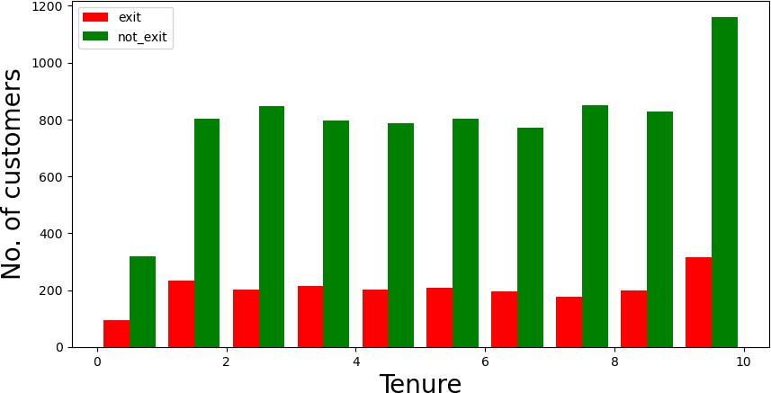
visualization(df_churn_exited,df_churn_not_exited,"Tenure")
1

In [24]:

1 | df_churn_exited = df [df['Exited']==1]['Age']
2 | df_churn_not_exited = df[df['Exited']==0]['Age']

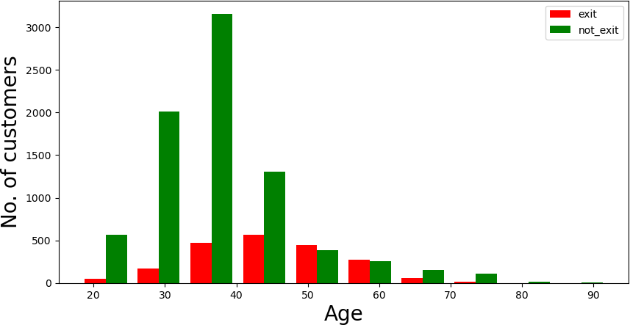
visualization(df_churn_exited,df_churn_not_exited,"Age")
1

In [26]:
df.dtypes
1
Out[26]:
CreditScore int64
Geography object
Gender object
Age int64
Tenure int64
Balance float64 NumOfProducts int64
HasCrCard int64
IsActiveMember int64 EstimatedSalary float64 Exited int64
dtype: object

In [27]:

1 | x = df[['CreditScore','Gender','Age','Tenure','Balance', 'NumOfProducts','HasCrCard'
2 | states = pd.get_dummies(df['Geography'],drop_first= True)
3 | gender = pd.get_dummies(df['Gender'],drop_first= True)

In [28]:
df = pd.concat([df,gender,states], axis=1)
1

df.head()
1
Out[29]:

CreditScore Geography Gender Age Tenure Balance NumOfProducts HasCrCard Is
- 619 France Female 42 2 0.00 1 1
- 608 Spain Female 41 1 83807.86 1 0
- 502 France Female 42 8 159660.80 3 1
- 699 France Female 39 1 0.00 2 0
- 850 Spain Female 43 2 125510.82 1 1
In [30]:
x = df[['CreditScore','Age','Tenure','Balance', 'NumOfProducts','HasCrCard','IsActiv
1
In [31]:
y = df['Exited']
1
In [ ]:
1
In [32]:

1 | from sklearn.model_selection import train_test_split
2 | x_train,x_test,y_train,y_test = train_test_split(x,y,random_state=0, test_size=0.25)

In [33]:
1
x.shape
Out[33]:
(10000, 9)

In [34]:
1
x_test.shape
Out[34]:
(2500, 9)

x_train
1

Out[43]:
array([[-1.13575957, | -0.46944165, -0.70387817, | ..., | -1.02664045,
0.60325767, | -0.50290013],
[-0.42644403, | 1.73021217, 0.67859859, | ..., | 0.97405085,
0.2269567 , | 1.98846639],
[ 1.29030518, | 0.39129245, -1.39511655, | ..., | -1.02664045,
-1.36445846, | -0.50290013],
...,
[ 2.04074047, | 0.5825667 , -0.01263979, | ..., | 0.97405085,
1.61079312, | 1.98846639],
[-0.87876119, | -0.2781674 , -1.39511655, | ..., | -1.02664045,
-0.35801334, | -0.50290013],
[-0.38532429, | 0.20001821, -0.70387817, | ..., | 0.97405085,
1.37555676, | -0.50290013]])

In [35]:
x_test.shape
1
Out[35]:
(2500, 9)

In [36]:
x_train.shape
1
Out[36]:
(7500, 9)

In [37]:
In [39]:
In [40]:
ann.fit(x_train,y_train)
1
ann = MLPClassifier(hidden_layer_sizes=(100,100,100), random_state =0,
max_iter=100, activation='relu')
1
2
3
from sklearn.neural_network import MLPClassifier
1
C:\ProgramData\Anaconda3\lib\site-packages\sklearn\neural_network\_multila yer_perceptron.py:692: ConvergenceWarning: Stochastic Optimizer: Maximum i terations (100) reached and the optimization hasn't converged yet.
warnings.warn( Out[40]:
MLPClassifier(hidden_layer_sizes=(100, 100, 100), max_iter=100, random_sta te=0)

1 | from sklearn.metrics import ConfusionMatrixDisplay, classification_report
2 | from sklearn.metrics import accuracy_score

Out[49]:
In [42]:
Out[42]:
array([0, 0, 0, ..., 0, 0, 0], dtype=int64)
In [45]:
In [48]:
In [49]:
y_test.value_counts()
1
import sklearn
1
y_pred
1
y_pred =ann.predict(x_test)
1
0 1991
1 509
Name: Exited, dtype: int64

In [50]:
ConfusionMatrixDisplay.from_predictions(y_test,y_pred)
1
Out[50]:
<sklearn.metrics._plot.confusion_matrix.ConfusionMatrixDisplay at 0x2257a6 4b3d0>
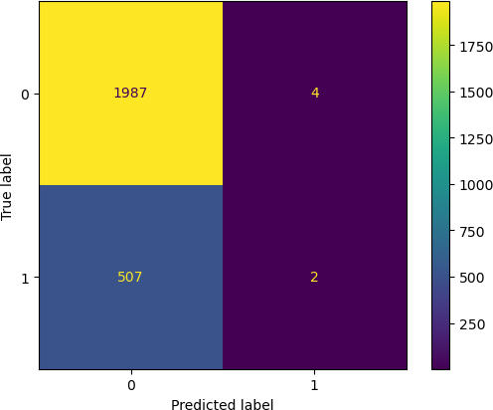

In [51]:
accuracy_score(y_test,y_pred)
1
Out[51]:
0.7956

In [52]:
print(classification_report(y_test,y_pred))
1

 | precision | recall | f1-score | support
0 | 0.80 | 1.00 | 0.89 | 1991
1 | 0.33 | 0.00 | 0.01 | 509
accuracy |  |  | 0.80 | 2500
macro avg | 0.57 | 0.50 | 0.45 | 2500
weighted avg | 0.70 | 0.80 | 0.71 | 2500

In [ ]:
1

